FOOTBALL CAREERS
SCHOLARSHIP & EDUCATION PROGRAMME
FOR 16-19 YEAR OLDS

IN PARTNERSHIP WITH

ALTRINCHAM FOOTBALL CLUB

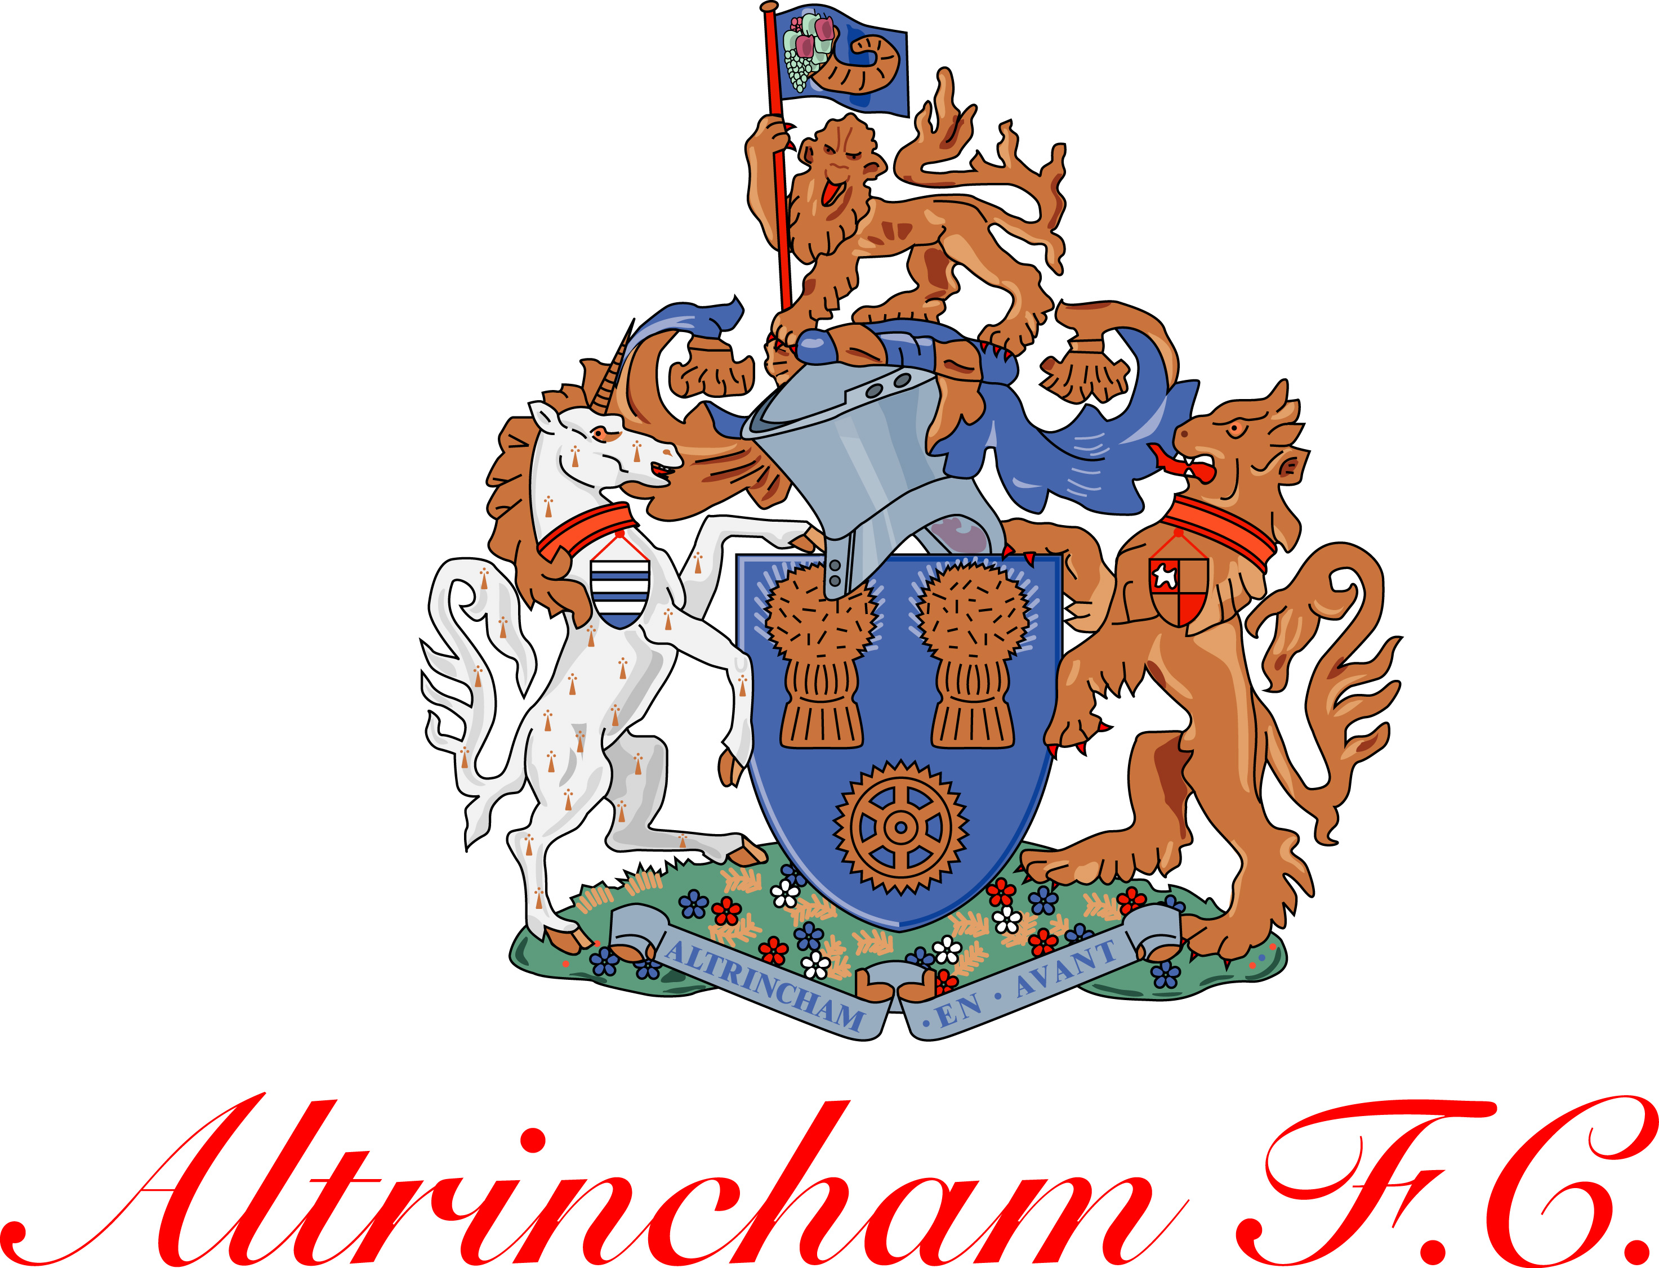

Do you want to continue your education and play & study football at the same time? If you are currently in Year 11 or aged 16-19 and wondering what your future holds, Interactive Sports have a unique opportunity that will allow you to play, train and compete like a professional footballer. Even if you’re not interested in the playing and training side, you can concentrate instead on the non-playing aspects of football. Both the playing and non-playing pathways for males and females allow you to study the many football industry career routes such as Teaching, Coaching, Physiotherapy, Match & Player Analysis, Strength & Conditioning, Officiating and Football Business all whilst continuing your full time education on a 2 Year BTEC Sports Course at a level to support your move into employment or University.

Learners complete their BTEC Course units vocationally, based in a football stadium environment, in classrooms overlooking the pitch. If following the playing/training pathway you will compete in the Conference Youth Alliance League and English Colleges F.A. League.

YOUR CHOICE, WHICH CAREER WOULD YOU LIKE TO FOLLOW?
Football Player Teaching Coaching Physiotherapy
Match & Player Analysis Strength & Conditioning Coach Officiating Football Business

PARTICIPATION IN THE FOOTBALL CAREERS SCHOLARSHIP & EDUCATION PROGRAMME HAS THE FOLLOWING BENEFITS:
- Provides individuals age 16-19 with the best opportunity to develop a career in football and the sports industry while continuing their full-time education
- Offers the expertise of experienced and highly qualified academic and coaching staff. Also being based at a football club offers the learners the opportunity to interact on a daily basis with all staff involved in the day to day running of a football club, such as the Chairman, Directors, Secretary, Coaches, Physio, etc.
- Provides individuals with up to 12 hours per week of professional training and matches for those following the playing/training pathway
- Enables individuals to compete against other teams from around the country for those following the playing/training pathway
- Provides excellent facilities
- Offers opportunities to progress into Professional/Semi-Professional Football, Higher Education, USA Scholarships and Employment.
The programme is fully funded and therefore free of charge.

To apply for a place on the Football Careers Scholarship & Education Programme for 16-19 year olds please contact:

Steven Mort, Programme Director
Mobile: 07540 418599
E-mail: info@interactivecompany.co.uk
Website: www.isportsgroup.co.uk

